Introduction to Africa Map
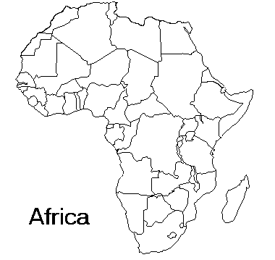

Countries to know: Features to know:
- Democratic Republic of the Congo - Nile River
- Egypt - Atlas Mountains
- Kenya - Congo River
- Sudan
- South Africa
- South Sudan
- Nigeria
Introduction to Africa Note Frames
- Environmental Issues
  - _________, fertilizers, _________ _________, storm runoff, _________ and manufacturing byproducts all contribute to _________ _________.
  - _________ places in Africa have plumbing for water or sanitations to _________ drinking water.
- The Sahara Desert in North Africa continues to grow due to _________. The three reasons for desertification are:
  - _________
  - Poor _________ practices
  - _________ and _________
- Where do people live?
  - _________: people are usually nomads here
  - Sahel: _________ zone from Sahara to the Rainforest
  - Savanna: rolling _________ with scattered trees and shrubs where most people live along the _________ or the _________ River.
  - _________: lush plant life with a wide variety of _________
- Religions in Africa
  - _________ - Ethnic group living in western Africa. They believe in _________ - plants, animals, and trees have souls.
  - Bantu- Beliefs based on culture and _________. Approximately _________ African languages have Bantu roots.
  - Swahili- Include all _________ living in a narrow strip from Kenya to Tanzania. They usually have a high _________ of _________.
- Education
  - About 85% of Kenyans attending _________. In _________ Kenya, only about _________ of the children attend school.
  - In _________, education has suffered because of their civil war.
- Apartheid
  - South Africa was colonized by the _________ and _________ in the 17th century.
  - In _________, the apartheid separated the country into whites and non-whites.
  - In May 1961, the South Africans voted for and gained their _________ from Britain. It took many protests and powerful leaders for this to occur.
- Nelson Mandela
  - A leader in the _________ African National Congress (ANC) who was arrested in 1962.
  - He was sentenced to life in prison in 1964 for _________ and _________
  - He emerged as the international symbol of resistance to apartheid, and the world community demanded his _________.
  - President de Klerk ended the ban on the ANC and released some political prisoners, including _________.

