Africa’s Independence Movements
Directions: Complete the timeline chart below with information from the presentation. Please summarize the event that occurred on each date in your own words.

Date | Event
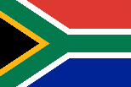
South Africa

1600s
1910
1948
1951
1960
1961
1994
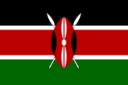
Kenya

1800s
1900s
1920s
1956
1963
1978
1990s
Nigeria

1914
1950s
1957
1960
1966
1999

