- Two rivers that start high in the Himalayas

- Gobi Desert

- Ganges River

- Mekong River

- Himalayan Mountains

- Yangtze River

- Effects of the pollution of the Yangtze River

- Causes of air pollution in China

- Causes of flooding in India and China

- Solutions to the pollution and flooding problems in India and China

- Taj Mahal

- Monsoons

- About 90 percent of China’s population lives where

- Where do most people in Southern and Eastern live

- Religious group

- Ethnic group

- Buddhism

- Shintoism

- Hinduism

- Islam

- Confucianism

- Factors leading to the creation of the modern state of Israel

- Persian Gulf War

- Basis of Israel’s economy

- Mixed Economy

- Infrastructure

- Saddam Hussein

- Invasion of Afghanistan

- Osama bin Laden

- Specialization

- Anti-Semitism

- Zionism

- Arab-Israeli Conflict

- Ottoman Empire

- Human capital

- Quota

- Tariff

- Command Economy

- Theocracy

- 1948

- Sunnis and Shias (Shiites)

- Foreign Exchange System

- Impact of oil on SW Asia’s economy

- Reason for Israel’s high standard of living

Discussion: (worth 5 questions)
Answer in complete sentences in paragraph form:
Describe one conflict in the Middle East that involved the United States.
Briefly explain why the United States was involved.
Make sure you have covered the following topics in your paragraph:
Where did the conflict occur?
Which countries were involved?
Why did the conflict occur?
What was the outcome?
Why did the United States get involved?
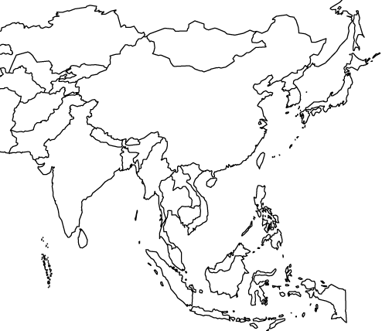Label Countries and Features:
China India Vietnam Indonesia Japan North Korea South Korea
Ganges River Huang He (Yellow) River Indus River Yangtze (Chang Jiang) River
Mekong River Bay of Bengal Indian Ocean Sea of Japan Yellow Sea
Gobi Desert Taklimakan Desert Himalayan Mountains Korean Peninsula
South China Sea Pacific Ocean

