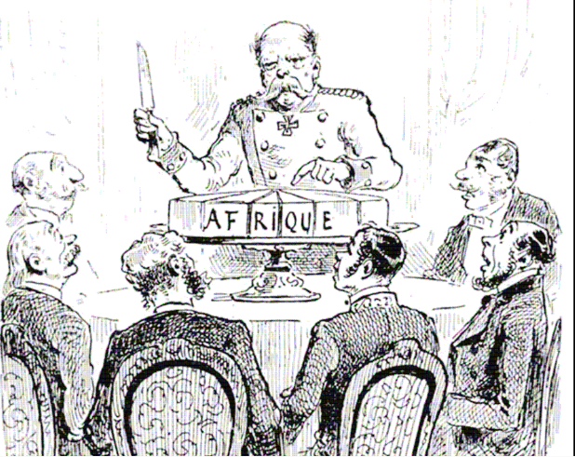
- Describe the action taking place in the cartoon:

- Explain the message of the cartoon:

- What group would agree with the cartoon’s message? Why?

- What group would disagree with the cartoon’s message? Why?

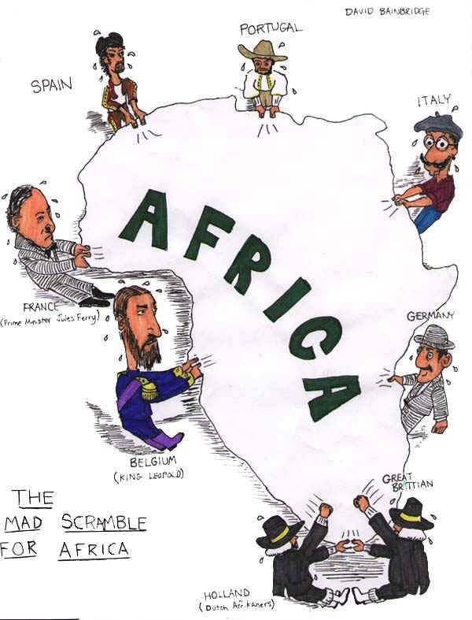

- Describe the action taking place in the cartoon:

- Explain the message of the cartoon:

- What group would agree with the cartoon’s message? Why?

- What group would disagree with the cartoon’s message? Why?

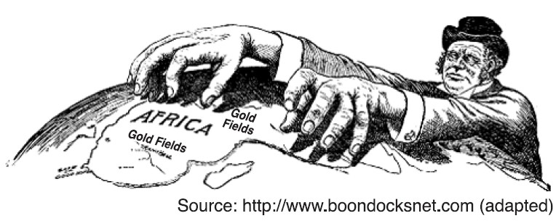

- Describe the action taking place in the cartoon:

- Explain the message of the cartoon:

- What group would agree with the cartoon’s message? Why?

- What group would disagree with the cartoon’s message? Why?

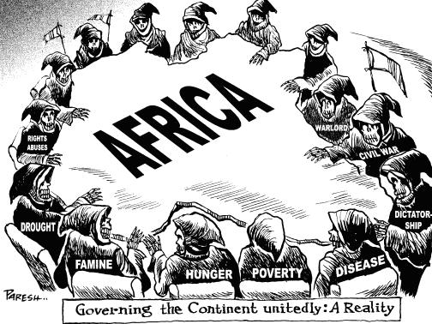

- Describe the action taking place in the cartoon:

- Explain the message of the cartoon:

- What group would agree with the cartoon’s message? Why?

- What group would disagree with the cartoon’s message? Why?

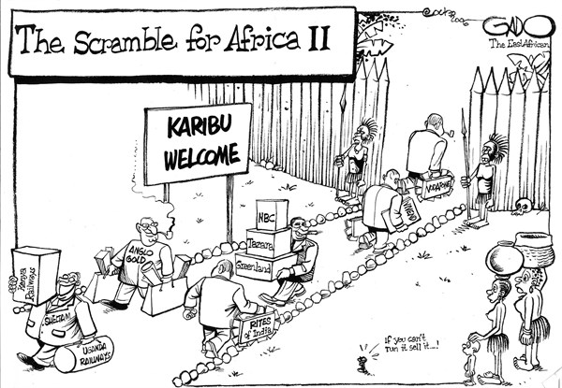

- Describe the action taking place in the cartoon:

- Explain the message of the cartoon:

- What group would agree with the cartoon’s message? Why?

- What group would disagree with the cartoon’s message? Why?

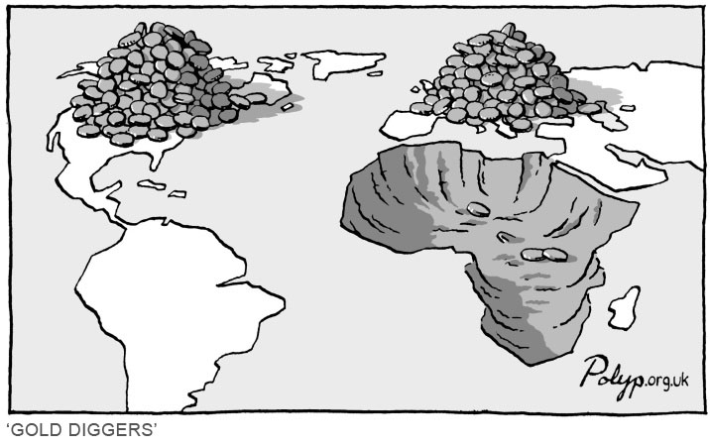

- Describe the action taking place in the cartoon:

- Explain the message of the cartoon:

- What group would agree with the cartoon’s message? Why?

- What group would disagree with the cartoon’s message? Why?

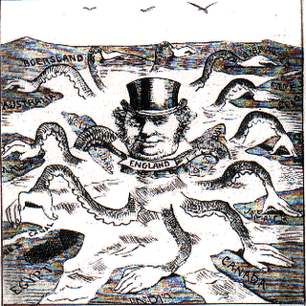

- Describe the action taking place in the cartoon:

- Explain the message of the cartoon:

- What group would agree with the cartoon’s message? Why?

- What group would disagree with the cartoon’s message? Why?

