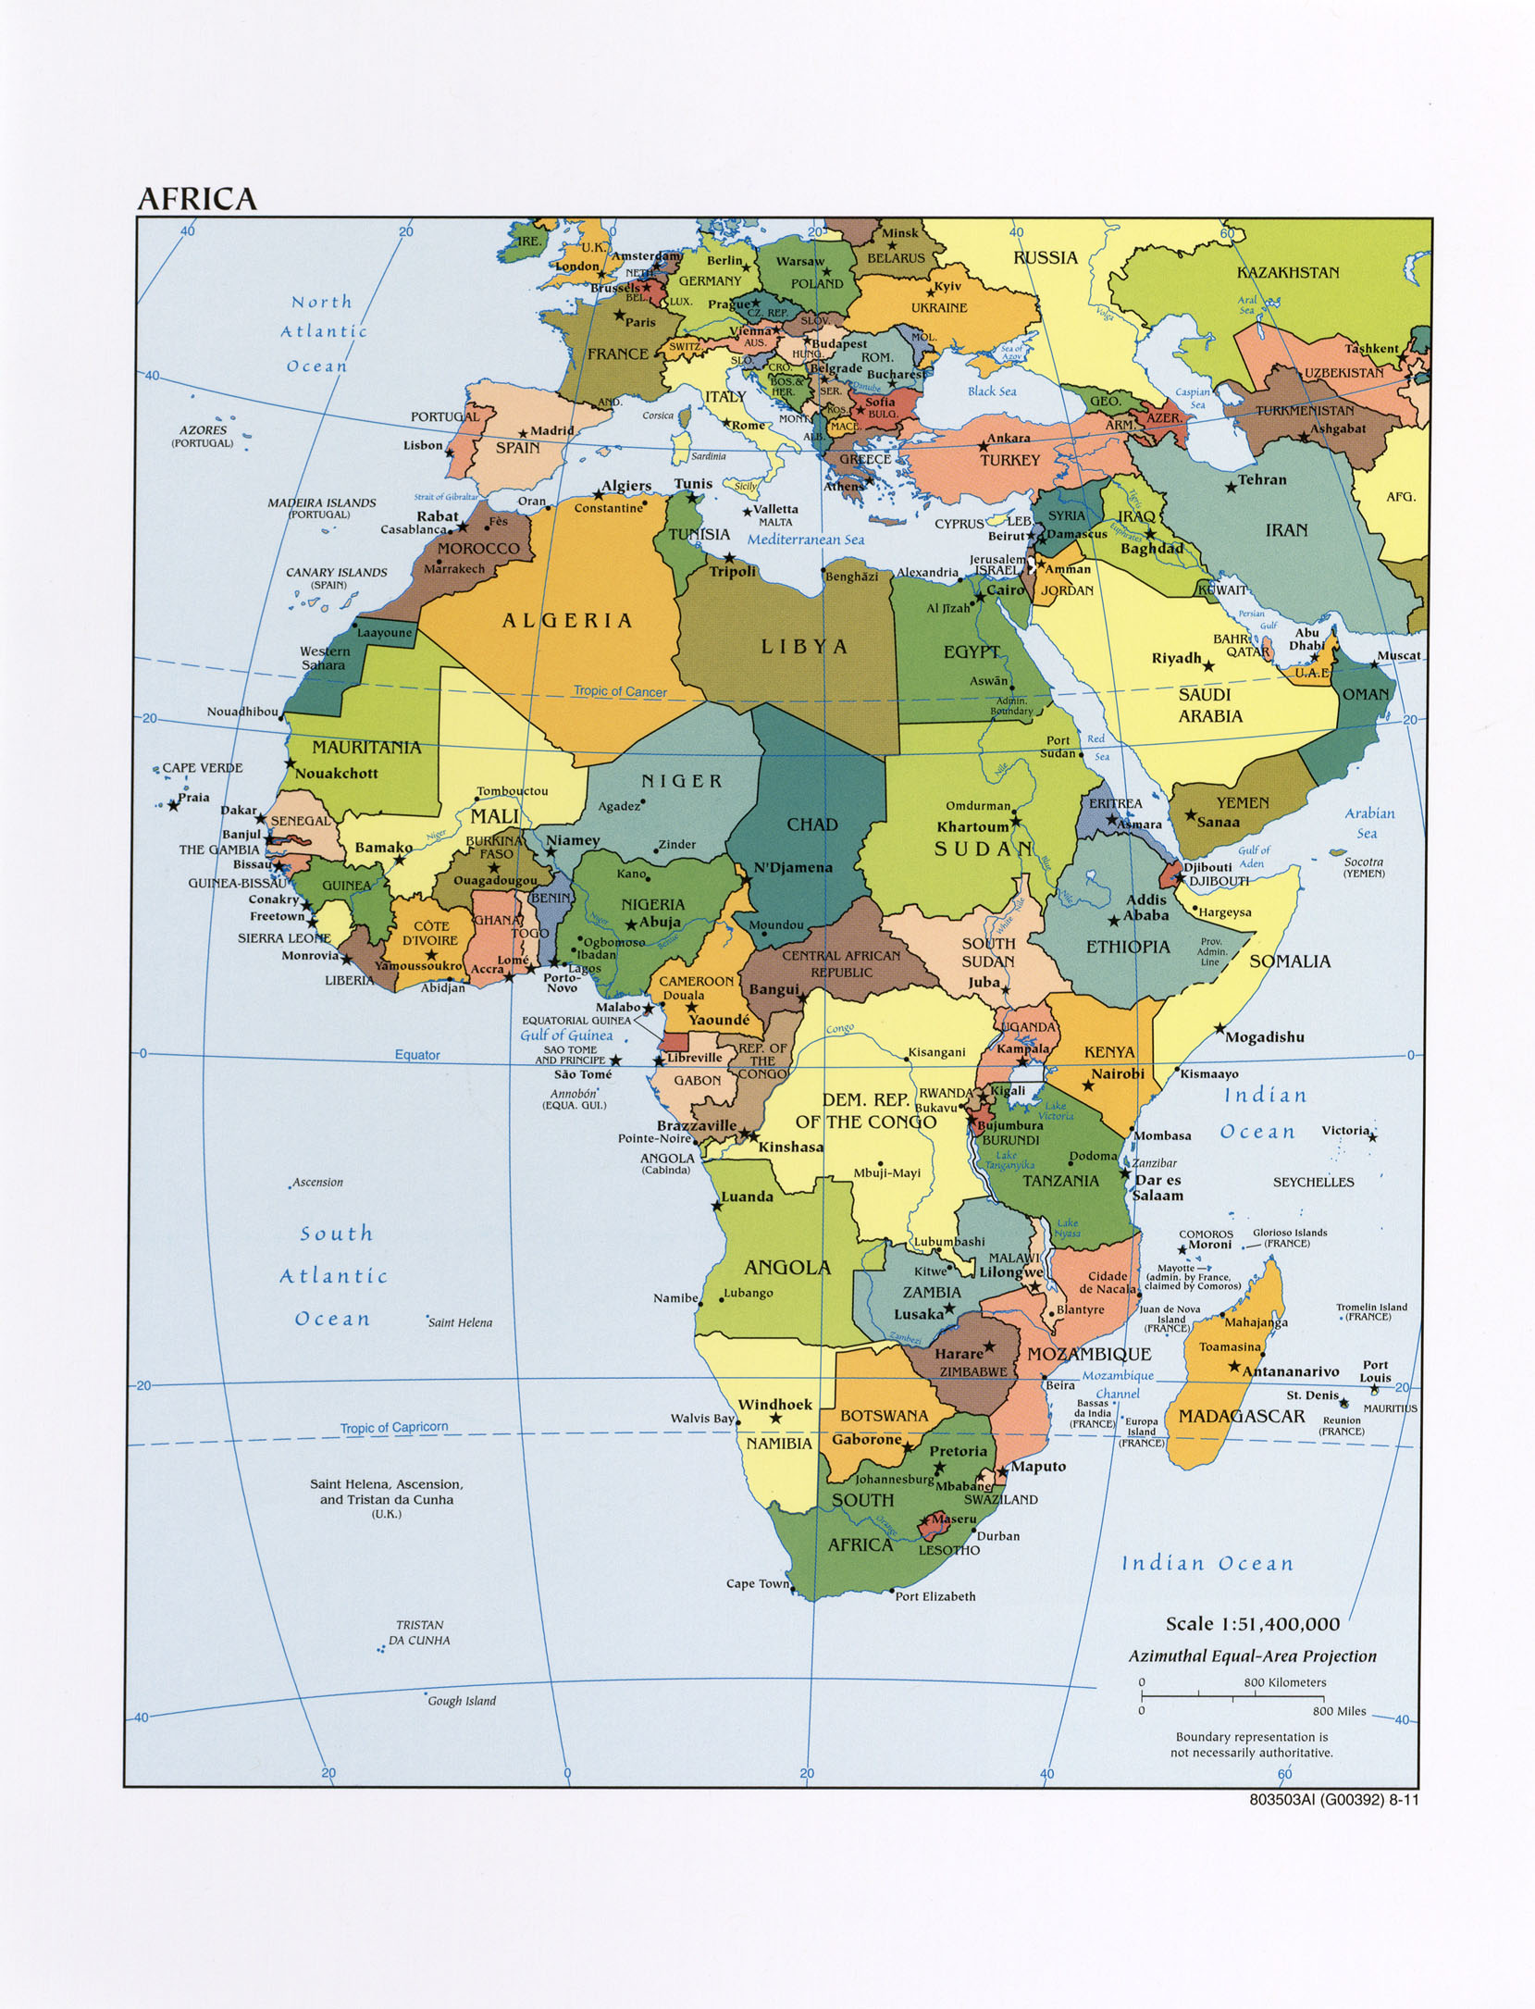

Station One

Station Two

[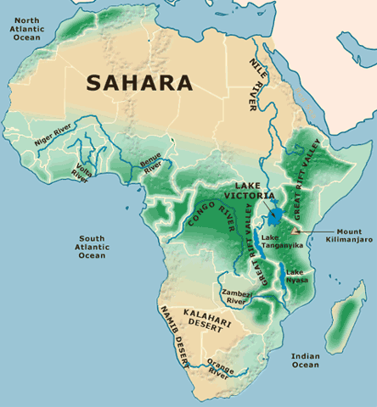](http://www.google.com/url?sa=i&rct=j&q=&esrc=s&source=images&cd=&cad=rja&uact=8&ved=0CAcQjRxqFQoTCNqWluCctccCFcIYkgodr0wBRA&url=http%3A%2F%2Fwww.geocoops.com%2Fafrica.html&ei=6YDUVZr-CMKxyASvmYWgBA&bvm=bv.99804247,d.aWw&psig=AFQjCNHGnkac560YsW8-oJ0iwHWi7JhF9A&ust=1440076391267193)

Station Three

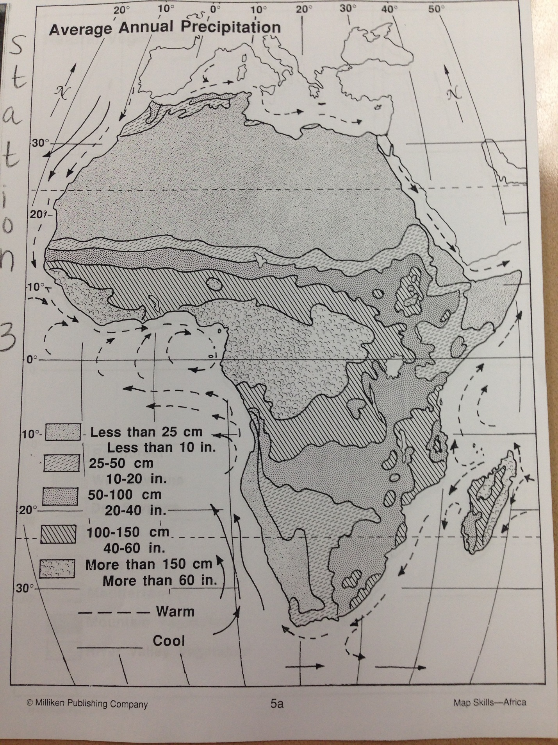

Station Four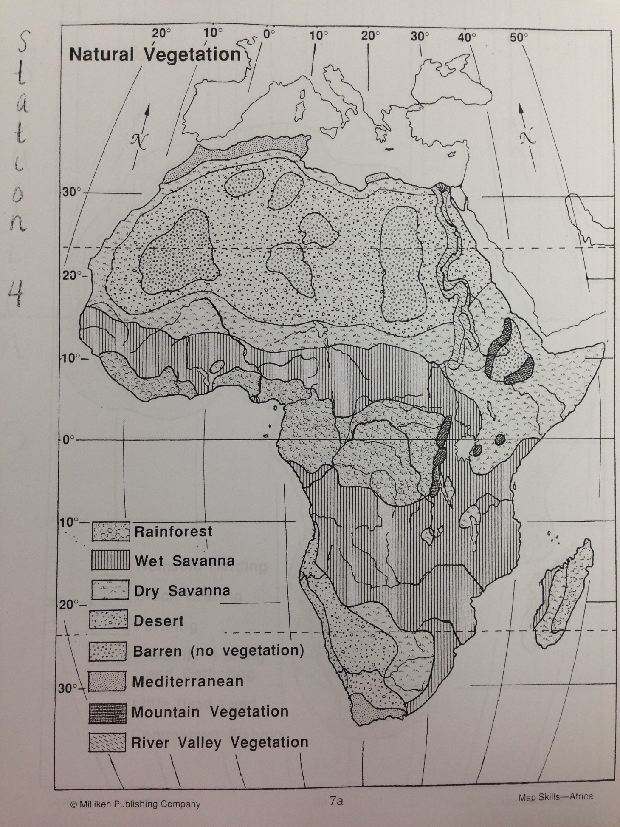

Station Five

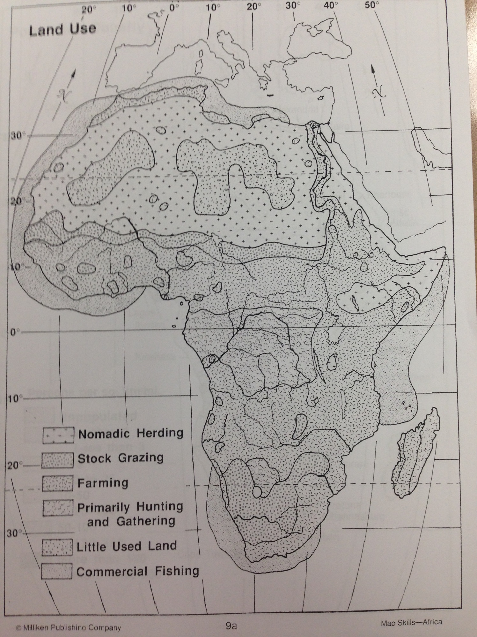

Station Six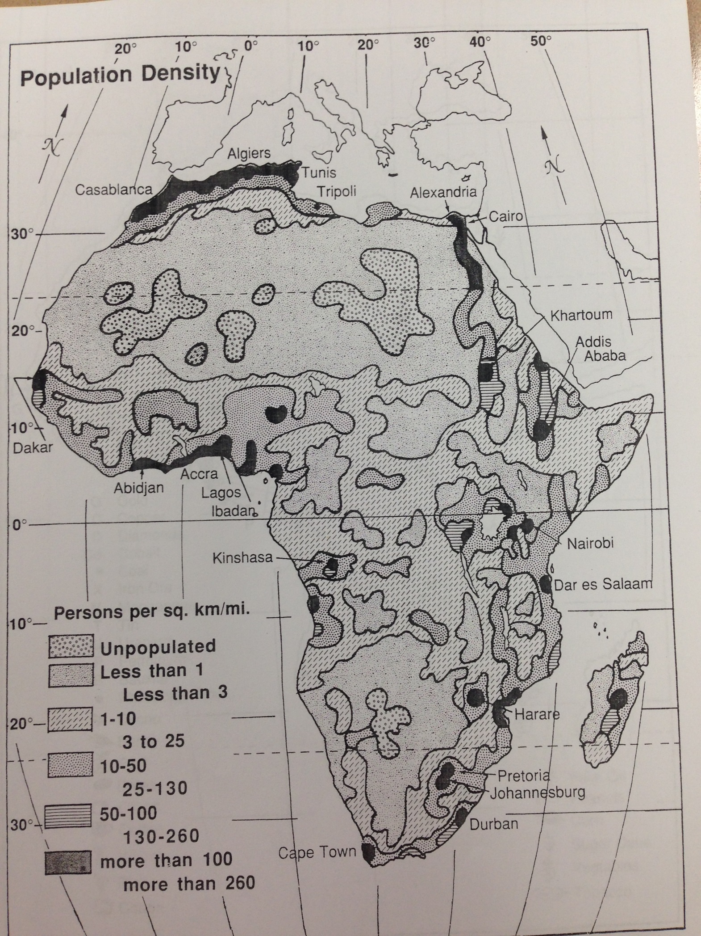

Station 7

S