Name _____________________________________ Class Period _______ Date ___________________________
After labeling your map of Southeast Asia, answer the following questions.
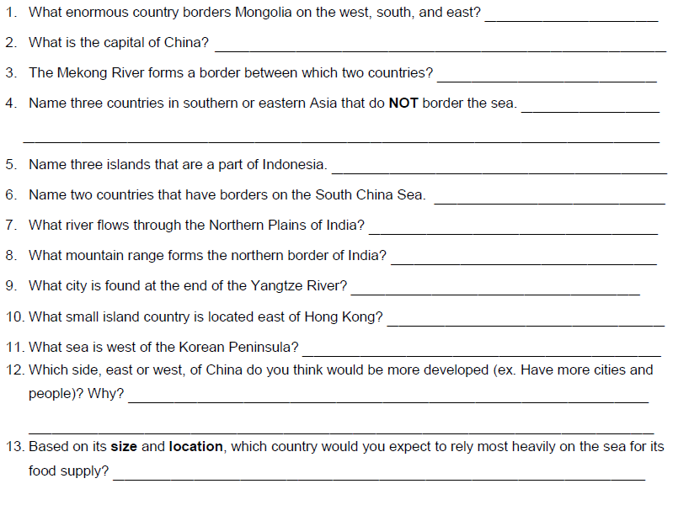
Complete the following geography sandwiches
14. India _________________________ China
15. Thailand ______________________ India
16. Vietnam ___________________ Philippines
17. North Korea __________________ Japan
18. South Korea ___________________ Taiwan

Make your own sandwich
19. _______________ ________________ _______________
Solve each analogy
20. Sea of Japan : Yellow Sea :: East China Sea : ______________
21. Yangtze River : China :: Ganges River : _______________
22. Ganges River : Bay of Bengal :: Yangtze River : ____________
23. Indus : river :: Gobi : __________
24. North Korea : South Korea :: Mongolia : ___________
Create your own analogy
25. _________ : ___________ :: ___________ : ____________

