**Unit 1: Government and Economics**

.

1. **What are the three main forms of government? How do they differ?**
2. **What are the ways citizens participate in their country?**
3. **What factors influence an economy?**

**SS7CG1, SS7CG4, SS7E1**

**1****732**

**What will I need to complete for this unit?**

**Assignment** **Due Date**

1. Government Mobile
2. Government Word Wall
3. Economy Word Wall
4. Notebook Check
5. Formal Assessment

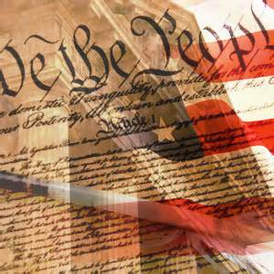

**Vocabulary**

1. Autocracy 1. Market Economy
2. Confederation 2. Mixed Economy
3. Presidential Democracy 3. Traditional Economy
4. Parliamentary Democracy 4. Command Economy
5. Monarchy 5. Human Capital
6. Unitary 6. Capital
7. Federal 7. Entrepreneur
8. Oligarchy 8. Tariff
9. Constitution 9. Quota
10. Theocracy 10 .Embargo
11. Communism 11. Foreign Exchange

|  |  |
| --- | --- |
| Autocracy |  |
| Confederation |  |
| Presidential Democracy |  |
| Parliamentary Democracy |  |
| Monarchy |  |
| Unitary |  |
| Federal |  |
| Oligarchy |  |
| Constitution |  |
| Theocracy |  |
| Communism |  |
| Market Economy |  |
| Mixed Economy |  |
| Traditional Economy |  |
| Command Economy |  |
| Capital |  |
| Human Capital |  |
| Entrepreneur |  |
| Tariff |  |
| Quota |  |
| Embargo |  |