**Unit 2: Geography of Africa**

Sahel

Savanna

Tropical Rainforest

Infrastructure

Landlocked

Irrigation

Deforestation

Desertification

Slash and Burn

Subsistence Farming

Ethnic Group

Religious Group

Arabs

Ashanti

Bantu

Swahili

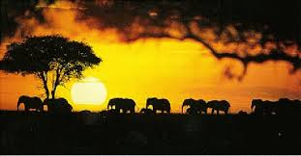

1. **What are the different geographical features of Africa?**
2. **What are the different environmental issues that are impacting Africa?**
3. **Where do people live in Africa and what do they do for work?**
4. **What are the different ethnic and religious groups in Africa?**

**Vocabulary**

**SS7G1, SS7G2, SS7G3, SS7G4**

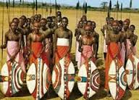

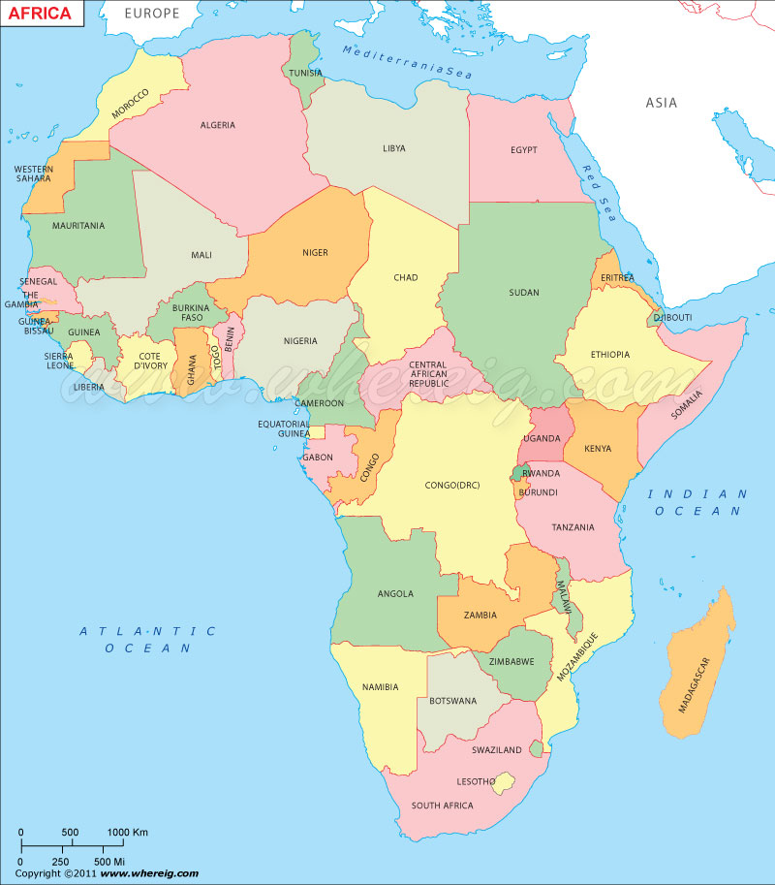

**COUNTRIES**

DRC

Egypt

Kenya

Sudan

South Africa

South Sudan

Nigeria

**PHYSICAL**

**FEATURES**

Great Rift Valley

Sahara

Sahel

Savanna

Tropical Rainforest

Congo River

Nile River

Niger River

Atlas Mountains

Kalahari Desert

Lake Tanganyika

Lake Victoria