SOUTH EAST ASIA

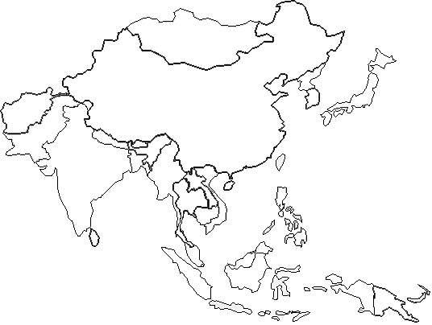

- In India, the _________________________________ is polluted with bacteria from human ashes, animal carcasses, and the sewage system
- Monsoons- _____________________________________________________________.
- Buddhism- 4th largest religion. Originated in___________________. Believe in ____________________, a cycle of birth and rebirth, where one’s behavior determines the next life.
- Hinduism- Largely practiced in India. (80% of Indians are Hindu) Believe in many gods (______________________). Believe _______________ determines your next life.
- Shintoism- Unique religion to ________________. Worship their ancestors, nature, life, and birth.
- Drawing of Gandhi:

- After Japan attacked the American military base in Pearl Harbor, the US dropped two atomic bombs on the cities of __________________________ and _____________________________.
- 1911- China had a new government called the________________________________________.
Review Questions Answer Sheet.
- 2. 3. 4. 5.

