A Picture is Worth a Thousand Words...

(Using Pictures to veiw Southern and Eastern Asia)

Title:

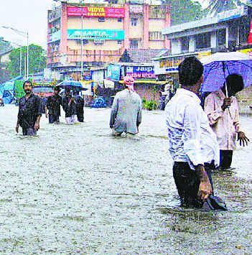

Title:

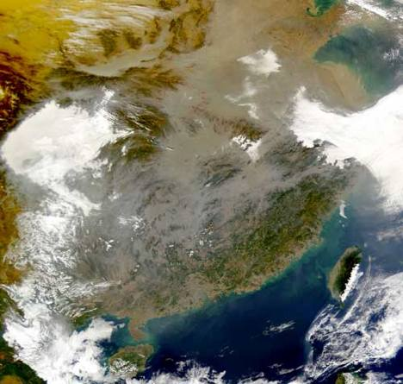

EFFECTS:

CAUSES:

Title:

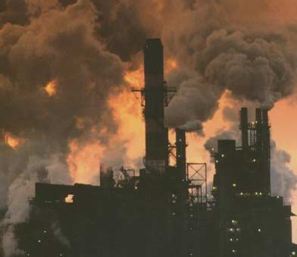

Circle: Explanation:

Yes or No

This Asian family is looking for a home in China. This beautiful home is located only minutes from this factory. Should they buy it, yes or no? Explain.





Title:

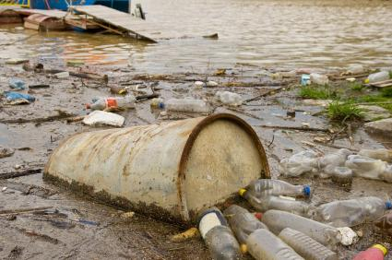

EFFECTS:

CAUSES:

Title:

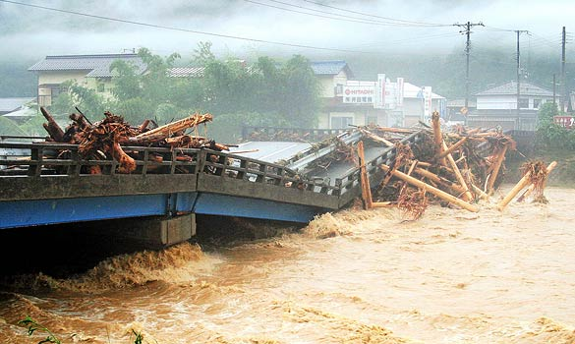

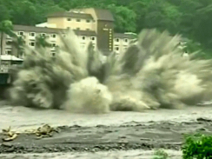

[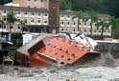](http://images.google.com/imgres?imgurl=http://www.jaunted.com/files/6193/TyphoonHotel.jpg&imgrefurl=http://www.jaunted.com/story/2009/8/10/11027/3340/travel/Biblical+Weather+Over+The+Weekend+In+Asia,+With+Two+Typhoons+And+An+Earthquake&usg=__5XUaIICtEpvicBD4ABdL6Zgce0A=&h=274&w=399&sz=83&hl=en&start=42&um=1&itbs=1&tbnid=jjgscuB00aeSmM:&tbnh=85&tbnw=124&prev=/images?q=typhoon+in+asia&start=40&um=1&hl=en&safe=active&sa=N&rlz=1T4GGLL_enUS340US349&ndsp=20&tbs=isch:1)

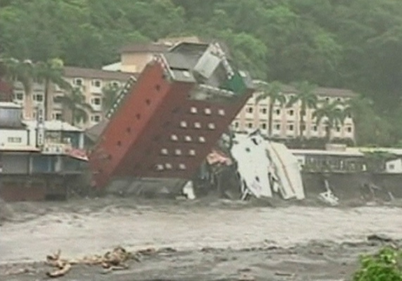

What could cause this type of destruction?

Title:

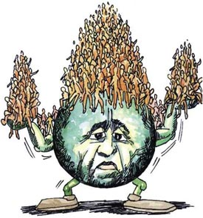

Contributing Role of China and India:

Intended Meaning of Cartoon:

P. 195