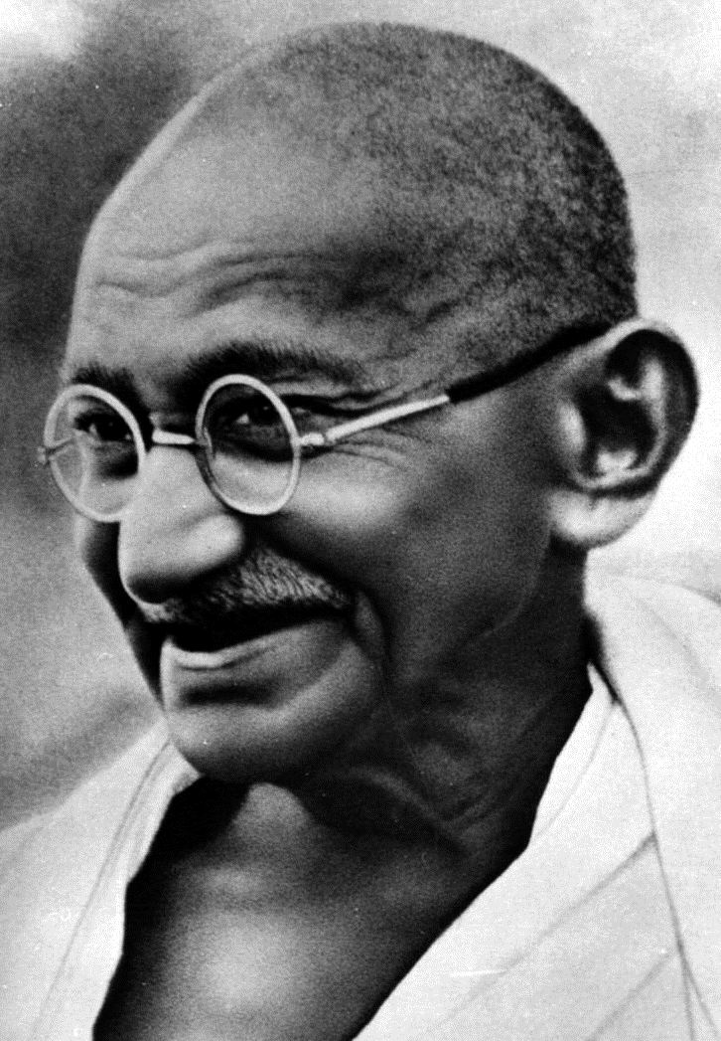
Gandhi: Pilgrim of Peace
A&E Biography

- How old were Gandhi and his wife when they got married?

- Why did Gandhi go to London?

- What happened to Gandhi on the train in South Africa?

- What was Gandhi’s first fight with injustice?

- What war did Gandhi fight in? For what country?

- What is satyagraha?

- What did Gandhi do to help Indian women?

- How did Gandhi protest laws in 1919?

- How did Gandhi’s clothes change? What did wearing western clothes symbolize to Gandhi and his supporters?

- Why was Gandhi a unique political leader for his time?

- What was the Salt March? What happened to Gandhi after the Salt March?

- Why did Britain finally decide to leave India? Why wasn’t Gandhi happy about India’s Independence?

- How many people died in the Hindu-Muslim fighting?

- What did Gandhi do in protest? What was the result of his protest?

- What happened on January 30, 1948?

- What was the main principle Gandhi believed?

